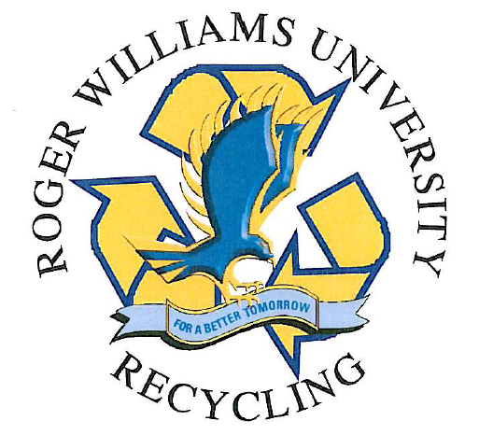

Campus Recycling and Waste Disposal Guide
Roger Williams University
Fall 2009

Recyclables
Batteries
Bottles / Cans / Glass (Commingled)
Cardboard
Cell Phones
Compact Fluorescent Bulbs (CFL’s)
Computer Monitors
Incandescent Bulbs
Paper
Plastic Containers (#1 and #2)
Printer Ink and Toner Cartridges
Televisions

Questions or Comments? Please contact:
Scott Yonan, Director of Special Projects (x3389) syonan@rwu.edu

Other Wastes
For aerosols, biohazardous wastes, chemical wastes, cylinders, mercury containing devices, pesticides, or radioactive wastes, please contact:
Cat Conley, Chemical Hygiene & Safety Officer (x3781) cconley@rwu.edu

Battery Recycling
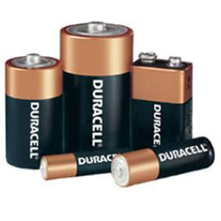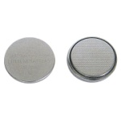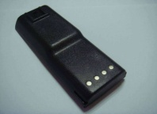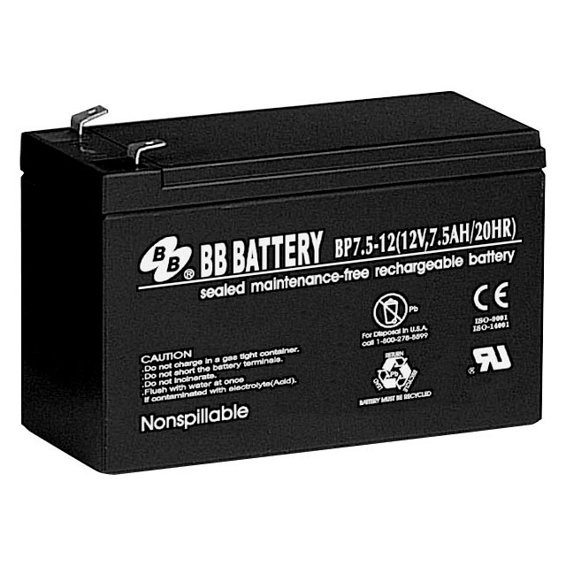
Definition:
Batteries are classified as Universal Waste by the Rhode Island Department of Environmental Management (RIDEM). Universal wastes are special wastes that contain chemical components and therefore cannot be thrown in the trash. Different kinds of batteries contain different chemicals, including potassium hydroxide, sulfuric acid, lead, nickel, cadmium, and silver.
Some common battery types include:
- Alkaline (AA, AAA, C, D, 9 Volt, etc)
- Lithium (Li)
- Nickel-Cadmium (NiCd)
- Lead-acid (Pb)
- Less common types include silver-oxide (Ag) and nickel-metal hydride (Ni-MH)
For more information on Rhode Island's battery disposal laws, please visit the RIDEM "Universal Waste Fact Sheet" website (website is a .pdf document - you will need Adobe Acrobat Reader to view).
Disposal:
All batteries must be collected in special receptacles located around campus. The battery recycling containers and battery recycling logos look like this:
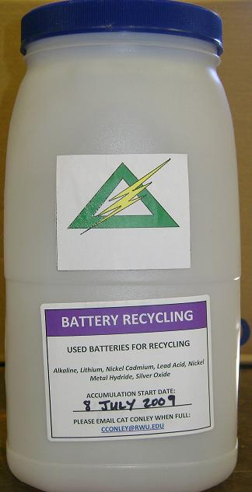
Logo Container
- If the battery is too large to fit into the container, please call or email CHSO Cat Conley (x3781) to arrange disposal.
- If your area is in need of a collection container, or if your container is full and you need an extra pickup, please contact CHSO Cat Conley (x3781)
- All of the battery recycling containers are made by re-using 1-gallon mayonnaise jars collected from the Dining Commons. EHS Department members and work-study students clean, label, and distribute the containers around campus.
Locations:

Building | Location
Administration | Front Desk
Admissions | Custodial Closet
Baypoint | Front Desk
Dining | Custodial Closet (105)
Dining | Ground Floor Recycling Area by ID Office
ELS | Custodial Closet
Facilities | CHSO Office (135)
Facilities | Custodial Closet
Facilities | Electrical Shop
Facilities | HVAC Shop
Facilities | Mechanical Shop
Facilities | Public Safety Break Room
Facilities | Universal Waste Accumulation Area
Gabelli Business | Custodial Closet
Gabelli Business | Front Entrance Recycling Area
Intercultural Center | 1st Floor Meeting Room
IT | Front Desk
Law School | Basement Café Recycling Bin
Library | Custodial Closet 1st Floor
Library | Lobby Recycling Center (Ink Cartridges)
Library | Media Services
Mail Room | On top of Ink Cartridge Recycling Bin
MNS | 206 (Stockroom)
MNS | 2nd Floor Lounge
MNS | Custodial Closet
Nike | Custodial Closet
Performing Arts | Theater Shop
Rec Center | Custodial Closet 1st Floor by Café
Rec Center | Custodial Closet 2nd Floor by Conference Room
Rec Center | Custodial Closet by CEN
Rec Center | Gym Front Desk
SAAHP | Second Floor Faculty Offices
School of Engineering | 127 (Administrative Reception Desk)
Student Life | Housing (Front Desk)

Back to top

Commingled Recyclables
(Bottles, Cans, and Glass Beverage Containers; #1 and #2 Plastics)

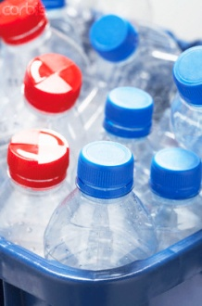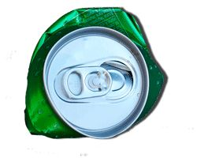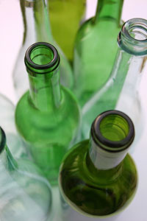

Definition:
"Commingled recyclables" means all beverage containers (plastic bottles, aluminum cans, and glass bottles). These containers can all be placed in the same commingled recycling container. #1 and #2 Plastic containers may also be recycled in these receptacles.
Disposal:
There are three types of indoor commingled recycling receptacles on campus - tall green boxes, Blue/Green Toters, and 55 gallon yellow drums. Additionally, there are outdoor receptacles located around campus that are labeled as commingled receptacles. All Dumpster sites near the residence halls have a blue toter that is labeled for commingled cans and bottles (adjacent the blue toter that is labeled for paper only).

Photos of the indoor receptacles are shown below:

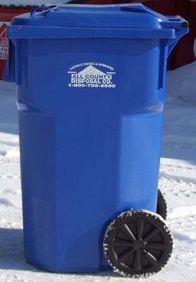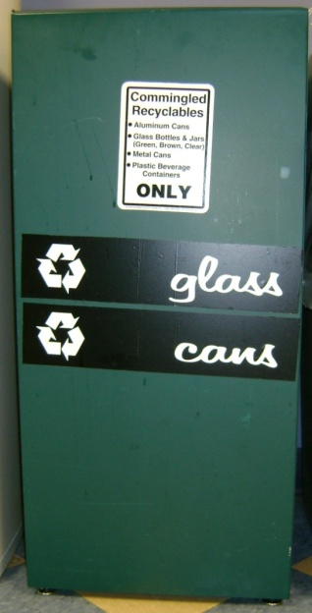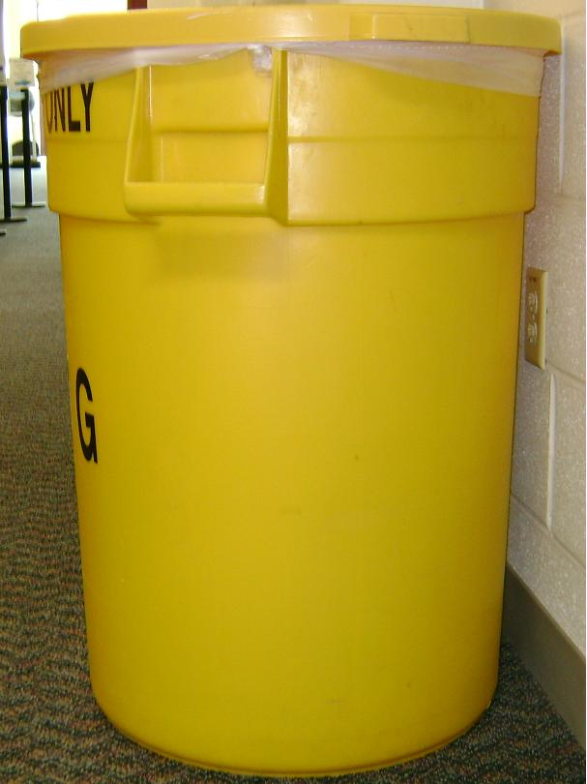

Toter Tall Green Box Yellow Drums

Indoor Commingled Recycling Locations:

Building | Location | Type
Administration Building | Foyer near the stairs | 1 x Green Box
Bayside | Outside Whitecap | Toter
Bayside | Outside Tidewater | Toter
Bayside | Outside Seabreeze | Toter
Cedar | All Floors – Waste Area (main stairs) | 1 x 55 gal yellow drum
College of Arts & Sciences | CAS 122 | 1 x Green Box
College of Arts & Sciences | Express Café Area | 1 x Green Box
College of Arts & Sciences | CAS 162 | 1 x Green Box
College of Arts & Sciences | Ladies Room (middle) | 1 x Green Box
Facilities | Public Safety Break Room | 1 x Green Box
Facilities | Facilities Break Room | 1 x Green Box
Facilities | Human Resources Break Room | 1 x Green Box
Gabelli School of Business | Left of vestibule in front hallway | 1 x Green Box
Gabelli School of Business | Hallway by back door | 1 x Green Box
Gabelli School of Business | Second Floor front stairs next to SB 223 | 1 x Green Box
Gabelli School of Business | Second Floor next to SB 222 | 1 x Green Box
Gabelli School of Business | Third Floor by back stairs | 1 x Green Box
Gabelli School of Business | Next to back door and vending machine | Toter
Law School | First Floor Lobby | 1 x Green Box
Law School | First Floor Kitchen (Library) | 1 x Green Box
Law School | Bay View Room | 1 x Green Box
Law School | Room 224 | 1 x Green Box
Law School | Second Floor Kitchen | 1 x Green Box
Library | First Floor Mail Area | Toter
Library | First Floor Front Door | Toter
Maple | All Units - Lounge | 1 x 55 gal yellow drum
Marine and Natural Sciences | Lobby | 1 x Green Box
Marine and Natural Sciences | First Floor Kitchenette | 1 x Green Box
Rec Center | Hawk's Nest Area | 1 x Green Box
Rec Center | Weight Room | 1 x Green Box
Rec Center | Student Programs and Leadership Office | 1 x Green Box
SAAHP | First Floor Student Lounge | 1 x 55 gal yellow drum
SAAHP | First Floor Studio near library | 1 x 55 gal yellow drum
SAAHP | Second Floor Upper Studio South Corridor | 1 x 55 gal yellow drum
SAAHP | Second Floor Upper Studio North Corridor | 1 x 55 gal yellow drum
SEECM (Engineering) | First Floor Foyer | 1 x 55 gal yellow drum
SEECM (Engineering) | Outside of SE 126 | 1 x 55 gal yellow drum
SEECM (Engineering) | First Floor South Side Entrance | 1 x 55 gal yellow drum
SEECM (Engineering) | SE 204 | 1 x 55 gal yellow drum
Stonewall | All buildings – First Floor Kitchen Area | 1 x 55 gal yellow drum
Student Development | Career Center Office | 1 x Green Box
Student Development | Front Door Vestibule | 1 x Green Box
Student Development | Health Center Waiting Room | 1 x Green Box
The Commons | Lower Commons | 1 x Green Box
The Commons | Lower Commons Private Dining Room | 1 x Green Box
The Commons | Upper Commons (by dish room) | 1 x Green Box
Willow Hall | All Units - Lounge | 1 x 55 gal yellow drum

Back to top

Cardboard Recycling

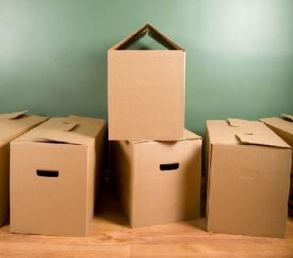

Definition:
Cardboard recyclables includes: corrugated cardboard, paper-board (non-corrugated cardboard), and cardstock (poster-board).

Pizza boxes and other food contaminated items are not recyclable!

Disposal and Locations:
To dispose of cardboard materials, flatten/breakdown any intact boxes, then place the flattened cardboard behind a paper recycling container (toter, paper recycling box, etc). RWU has cardboard dumpsters at the cafeteria loading dock and behind the Facilities building.

Back to top

Cell Phone Recycling

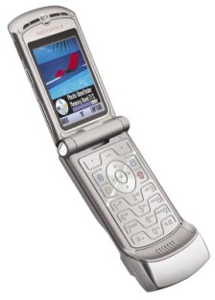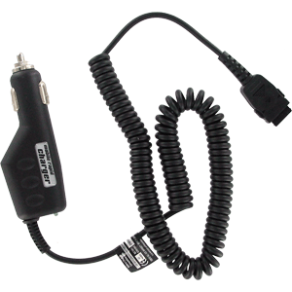

Definition:
Cell Phone recyclables includes: Cell phones and their associated accessories (chargers, belt clips, etc).

Disposal and Locations:
Cell phones may be recycled on campus or off-campus. The RWU Law School dining area (outside the bookstore) has a cell phone recycling drop site where phones may be deposited. If you wish to dispose of old cell phone batteries, you can do that at any battery recycling site.

Various charities also accept cell phones for recycling: typing the phrase “Cell Phone Recycling for Charity” into any search engine will yield hundreds of results. The websites will send you a mailing envelope or a postage-paid mailing label and you can mail in your old phones.

Back to top

Compact Fluorescent Bulbs

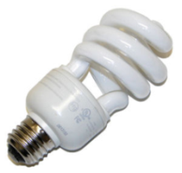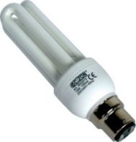

Definition:
Compact Fluorescent Bulbs (CFL’s) are classified as Universal Waste by the Rhode Island Department of Environmental Management (RIDEM). Universal wastes are special wastes that contain chemical components and therefore cannot be thrown in the trash.

For more information on Rhode Island's battery disposal laws, please visit the RIDEM "Universal Waste Fact Sheet" website (you will need Adobe Acrobat Reader to view).

Disposal and Locations:
CFL’s contain mercury, so handle them carefully and do not dispose of them in the trash.

Intact CFLs
Carefully place the CFL in a Ziploc bag, zip the bag closed, then additionally seal the bag with a piece of tape. The CFL may be brought to SAAHP (outside the faculty offices, 2nd Floor), Facilities (CHSO Conley’s Office, Room 135), or the Law School Dining Area.

Broken CFLs
Light bulbs are fragile, and it’s not uncommon for them to crack or break. In the event that a CFL is broken, the Environmental Protection Agency (EPA) has issued the following guidelines for CFL cleanup:

Before Clean-up: Air out the Room
- Have people and pets leave the room, and don't let anyone walk through the breakage area on their way out.
- Open a window and leave the room for 15 minutes or more.
- Shut off the central forced-air heating/air conditioning system, if you have one.
Clean-Up Steps for Hard Surfaces
- Carefully scoop up glass pieces and powder using stiff paper or cardboard and place them in a glass jar with metal lid (such as a canning jar) or in a sealed plastic bag.
- Use sticky tape, such as duct tape, to pick up any remaining small glass fragments and powder.
- Wipe the area clean with damp paper towels or disposable wet wipes. Place towels in the glass jar or plastic bag.
- Do not use a vacuum or broom to clean up the broken bulb on hard surfaces.
Clean-up Steps for Carpeting or Rug
- Carefully pick up glass fragments and place them in a glass jar with metal lid (such as a canning jar) or in a sealed plastic bag.
- Use sticky tape, such as duct tape, to pick up any remaining small glass fragments and powder.
- If vacuuming is needed after all visible materials are removed, vacuum the area where the bulb was broken.
- Remove the vacuum bag (or empty and wipe the canister), and put the bag or vacuum debris in a sealed plastic bag.
Clean-up Steps for Clothing, Bedding and Other Soft Materials
- If clothing or bedding materials come in direct contact with broken glass or mercury-containing powder from inside the bulb that may stick to the fabric, the clothing or bedding should be thrown away. Do not wash such clothing or bedding because mercury fragments in the clothing may contaminate the machine and/or pollute sewage.
- You can, however, wash clothing or other materials that have been exposed to the mercury vapor from a broken CFL, such as the clothing you are wearing when you cleaned up the broken CFL, as long as that clothing has not come into direct contact with the materials from the broken bulb.
- If shoes come into direct contact with broken glass or mercury-containing powder from the bulb, wipe them off with damp paper towels or disposable wet wipes. Place the towels or wipes in a glass jar or plastic bag for disposal.

After cleaning up the CFL, set the collected debris aside and notify Environmental Health and Safety (Director Dan Gough at x3189 or CHSO Cat Conley at x3781). EHS will arrange a time to come by and pick up the CFL debris.

Back to top

Computer Monitors and Televisions

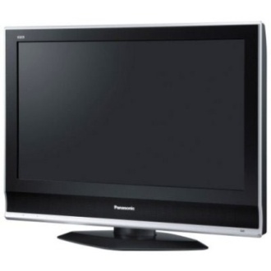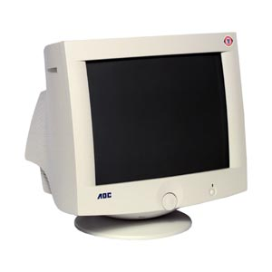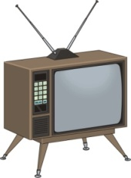

Definition:
Computer Monitors and Televisions includes: All TV’s and computer monitors (flat screen, bubble screen, etc). Computers and TV’s (CRT’s) of all types are classified as Universal Waste by the Rhode Island Department of Environmental Management (RIDEM). Universal wastes are special wastes that contain chemical components and therefore cannot be thrown in the trash. Televisions and computer monitors contain a variety of metals in their screens and other components, including lead and mercury.

For more information on Rhode Island's television and computer monitor disposal laws, please visit the RIDEM "Universal Waste Fact Sheet" website (website is a .pdf document - you will need Adobe Acrobat Reader to view).

Disposal and Locations:
No televisions or computer monitors may be thrown in the trash!
To dispose of a television or monitor:

STUDENTS: Notify your CORE that you have a television/monitor to recycle and they will coordinate a pickup with Facilities.

FACULTY AND STAFF: Follow these steps:

Place a work order with Facilities Management on the Facilities work order webpage.

- Click on the "Facilities Work Order" system hyperlink to enter the work order system.
- Enter in your contact information, then click "Yes" to proceed to the next page
- The Step One section ("Personal Information") will already be populated from the information you just entered on the previous page.
- In the Step Two section ("Location") - Enter your location information (building, room number, etc)
- In the Step Three section ("Problem Type") - Select "Moving"
- In the Step Four section ("Description") - Type in "Television(s) for recycling" or "Computer Monitor(s) for Recycling," how many units you have, and where the TV/monitor will be stored until pickup.
- In Steps 5-7 section, attach a photo of the TV(s) or Monitor(s) if you wish (not necessary), type in your submittal password, and select "Submit"
- Store the television in the location you picked in Step Four ("Description"). Ensure that the area is secure and out of the way so the TV/monitor won't get knocked over or disturbed.
- Facilities Management will pick up the television/monitor.

Back to top

Incandescent Bulbs

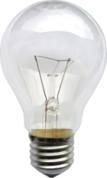

Definition:
Regular (non-fluorescent, non-mercury containing) light bulbs

Disposal and Locations:
Incandescent bulbs cannot be recycled and may be disposed of in the regular trash.

Back to top

Paper

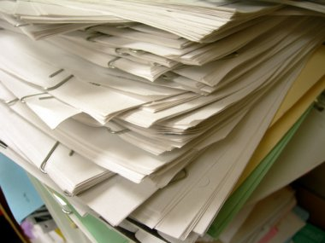

Definition:
Paper recycling includes: All office paper (any kind of ink), paper envelopes, post-it notes, papers, time cards, index cards, computer print-outs, color office paper, laser printed paper, accounting ledgers, letterhead stationery, loose-leaf paper, receipts, fax and telex sheets, scratch pads, copy and typing paper, NCR (no carbon required), envelopes with window, legal pads, brown paper bags, magazines, newspaper, cereal boxes, phone books, shredded paper.

Paper recycling does NOT include: pizza boxes, food wrappings, cardboard, wax paper, plastic coated papers, transparencies, tyvek envelopes, carbon paper, photographic or blueprint paper

Disposal and Locations:
Large blue “paper only” toters are available at each dumpster site near the residence halls (adjacent the labeled blue “commingled only” toters). Residential students may request a personal paper recycling bin for their room by contacting Scott Yonan (x3389). Residential students are responsible for emptying their own paper bins into these paper-only toters (Commingled recycling can be done in the residence halls – visit the list of locations).

Many offices have dedicated paper recycling bins. If your area does not have a paper recycling bin or toter, please contact Scott Yonan to obtain one (x3389).

Back to top

Ink and Toner Cartridges

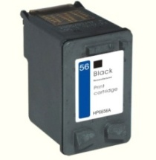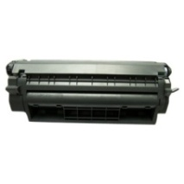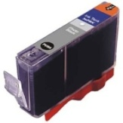
Definition:
Ink and toner cartridges are found in different kinds of printers. Laser printers use toner cartridges (carbon/polymer powder) to print images and text, whereas inkjet printers use ink cartridges.
Disposal:
To dispose of ink and toner cartridges, use any of the following five (5) methods:

- Use the pre-paid return label that came with the cartridge and send it back to the manufacturer via the mailroom.
- For smaller cartridges that did not come with a pre-paid return label or envelope, place the cartridge in an inter-office envelope and write "CARTRIDGE" in the “Deliver To” section. It will be picked up by the mailroom with the mail and will be emptied into a collection bin there, eventually being picked up by WB Mason for recycling.
- Give your empty cartridges to the person in your department who receives office supply deliveries from WB Mason. She/he will give the WB Mason delivery person the empties upon WB Mason's next delivery.
- Drop off your empty cartridges in the bin at the University Mailroom.
- There are some departments and student organizations that have special cartridge collection boxes that raise money for charities. Please continue to use those.

STUDENTS: You may give your empty cartridges to any staff member on-campus and they will be able to have them recycled using one of the methods above.

Back to top

